**Could Your Personality Derail Your Career?**

* [Tomas Chamorro-Premuzic](https://hbr.org/search?term=tomas%20chamorro-premuzic)

FROM THE SEPTEMBER–OCTOBER 2017 ISSUE

When considering what it takes to succeed at work, we often focus on innate strengths: high intelligence, the ability to learn, the ambition to achieve, and the social skills to develop strong relationships. But these characteristics always coexist with weaknesses—aspects of personality that might seem innocuous or even advantageous in some circumstances but that when left unchecked can wreak havoc on careers and organizations.

Two decades ago the psychologists Robert and Joyce Hogan created an inventory of these “dark side” traits—11 qualities that when taken to the extreme, resemble the most common personality disorders.

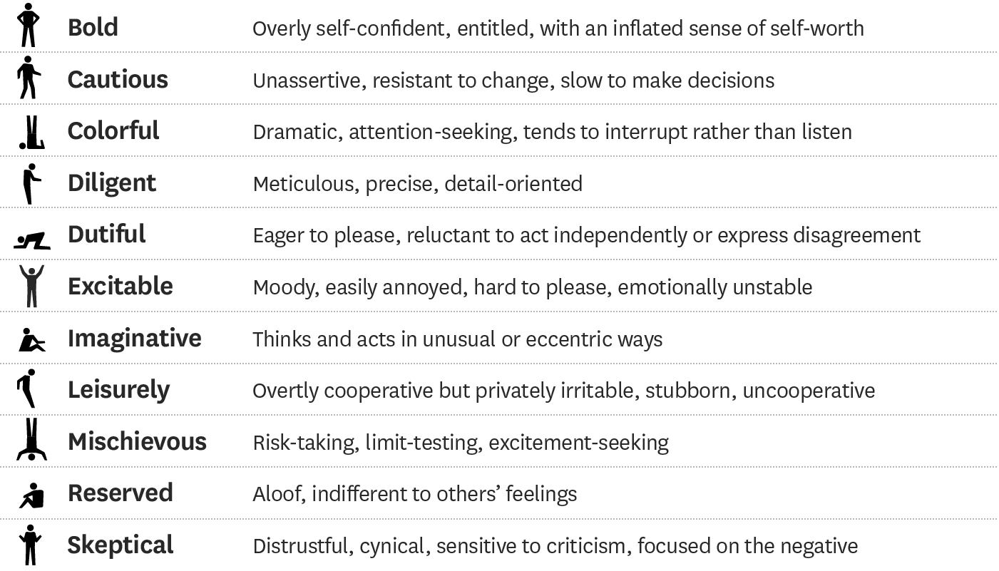

Since then their related assessment, the Hogan Development Survey (HDS), licensed by the eponymous company with which I am affiliated, has been widely adopted within the field of industrial-organizational psychology as a way to identify individuals’ development needs.

After profiling millions of employees, managers, and leaders, we know that most people display at least three of these dark-side traits, and about 40% score high enough on one or two to put them at risk for disruption in their careers—even if they’re currently successful and effective. The result is pervasive dysfunctional behavior at work.

Worryingly, leaders tend to do a poor job of evaluating their own dark sides, particularly as they gain power and move up the ranks. Some perceive their career advancement as an endorsement or encouragement of their bad habits. Eventually, however, those weaknesses may derail them, and perhaps their teams and organizations, too. For example,*cautious* leaders may convey the illusion of control and risk management in the short term, but being overly cautious may cause them to be so risk-averse that they obstruct progress and innovation. Being *excitable* may help you display passion and enthusiasm to coworkers and subordinates, but it can also make you volatile and unpredictable, which is taxing to others. *Diligence* helps you pay attention to details and strive to produce quality work, yet in excess it can morph into procrastination and obsessive perfectionism.

Research over decades suggests that it’s very difficult to change core aspects of your personality after age 30. But you can—through self-awareness, appropriate goal setting, and persistence—tame your dark side in critical situations, by changing your behaviors.

**Understanding the Dark Side**

Dark-side traits can be divided into three clusters.

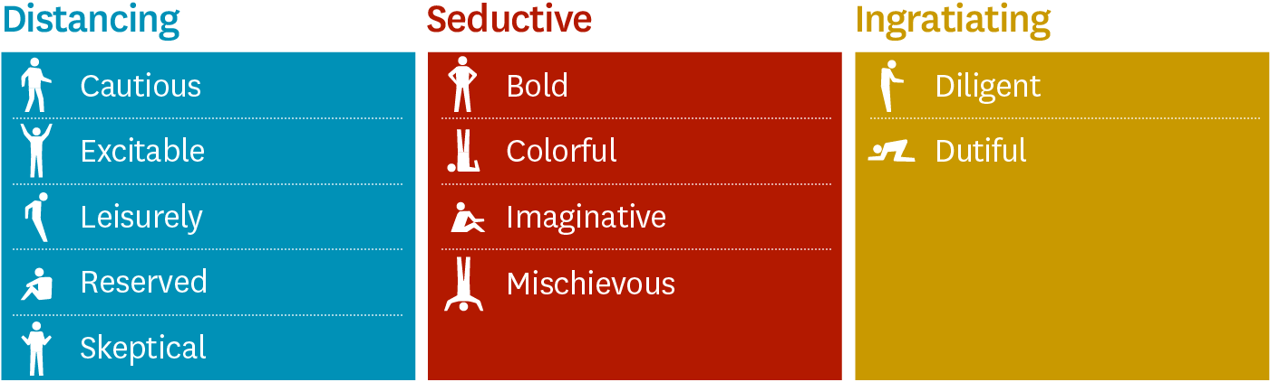

Those in the first are distancing traits—obvious turnoffs that push other people away. Being highly *excitable* and moody has this effect, for instance. So does having a deeply *skeptical,* cynical outlook, which makes it hard to build trust. Another example is *leisurely* passive-aggressiveness—pretending to have a relaxed, polite attitude while actually resisting cooperation or even engaging in backstabbing.

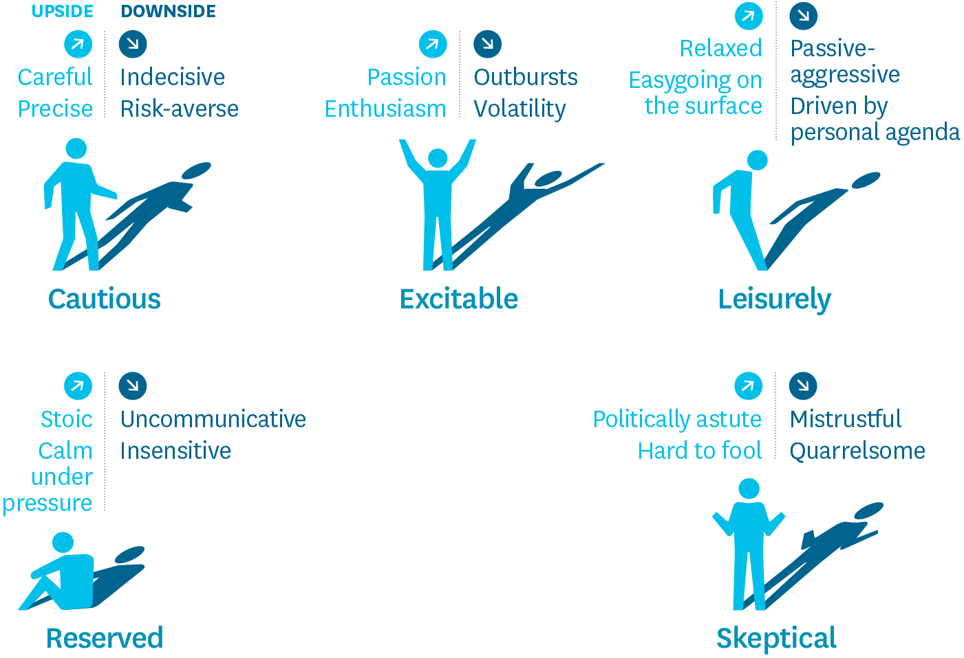

Traits in the second cluster are, in contrast, seductive qualities—geared to pull people in. They’re often found in assertive, charismatic leaders, who gather followers or gain influence with bosses through their ability to [“manage up.”](http://digitalcommons.unl.edu/cgi/viewcontent.cgi?article=1006&context=pdharms)But these traits can also have negative consequences, because they lead people to overestimate their own worth and fly too close to the sun. Being *bold* and confident to the point of arrogance is a good example; so is being puckishly*mischievous,* with an enormous appetite for reckless risk.

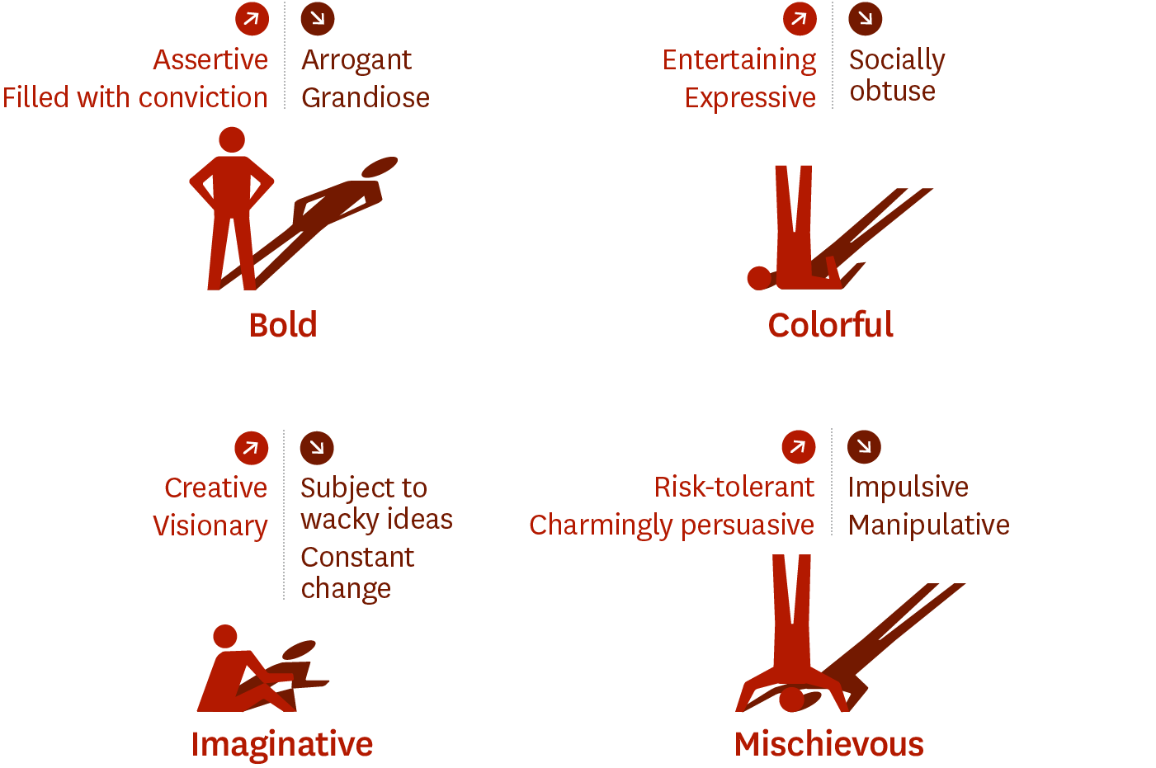

The third cluster contains ingratiating traits, which can have a positive connotation in reference to followers but rarely do when describing leaders. Someone who is *diligent,* for instance, may try to impress her boss with her meticulous attention to detail, but that can also translate into preoccupation with petty matters or micromanagement of her own direct reports. Someone who is *dutiful* and eager to please those in authority can easily become too submissive or acquiescent.

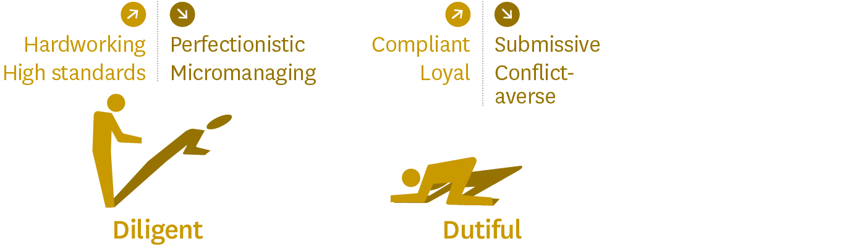

Not all dark-side traits are created equal. In a global meta-analysis of 4,372 employees across 256 jobs in multiple industries, distancing traits had a consistently negative impact on individuals’ work attitudes, leadership, decision making, and interpersonal skills (reflected in poor performance ratings and 360-degree reviews). But the seductive traits sometimes had [positive effects.](http://onlinelibrary.wiley.com/doi/10.1111/apps.12017/abstract) For instance, *colorful,* attention-seeking leaders often get better marks from bosses than their more *reserved* counterparts. And *bold,* ultra-confident CEOs often attain high levels of growth in[entrepreneurial ventures.](http://onlinelibrary.wiley.com/doi/10.1111/joms.12034/abstract) Dark-side traits also differ in their consequences. A *mischievous,* risk-taking leader who is under pressure to demonstrate financial growth can destroy an entire organization with a single impulsive decision. An*excitable* leader might simply wreck his career with a public temper tantrum.

It’s worth noting that a complete lack of these traits can be detrimental as well. An extremely calm, even-tempered, soft-spoken manager—someone who isn’t remotely *excitable*—may come across as dull or uninspiring. The key, then, is not to eliminate your personality weaknesses but to manage and optimize them: The right score is rarely the lowest or the highest but moderate.

Managing Your Dark Side   
If you are unable to complete a full psychological assessment to identify your potential derailers, you can take an abbreviated version of the HDS at [www.hoganx.io](http://www.hoganx.io/) (with registration required) or simply compare your typical patterns of behavior with the basic profiles of the traits. Even better: Ask bosses, peers, subordinates, and clients to give you honest and critical feedback on your tendency to display these traits. Tell them that you want to improve and need their candor. How do they see you when you’re not at your best? Do any of the traits sound a little (or a lot) like you? You might mention a pattern you’ve noticed or that others have commented on. You can improve your self-awareness through formal feedback mechanisms, such as performance appraisals, 360s, check-ins with your manager, and project debriefs. The key to gathering accurate information is to recognize that people will generally avoid offering critiques, especially to leaders, unless the behaviors are truly egregious. So in addition to assuring them that you welcome their honest assessments, you should listen carefully for subtle or offhand remarks.

**Case Study 1: From Getting Along to Getting Ahead**

Jane, the R&D manager of a global pharmaceutical company, is liked by her team and her boss, largely because of her emotional intelligence. However, her positive attributes are often eclipsed by her dark side. As someone who scores high on *dutiful*, Jane rarely disagrees with her reports and does so even less often with her boss, and she has real trouble providing negative feedback. She often underestimates big problems and rarely takes the initiative to suggest new ideas or projects. After her HDS scores revealed that these issues were rooted in her personality, Jane committed to making some changes. Her regular meetings with direct reports now start with a request: “Tell me what I can do better, and I’ll do the same for you.” She has become more assertive in critical situations: challenging the poor performers on her team, routinely presenting her manager with strategic recommendations, emphasizing things she “would do differently,” and joining a couple of blue-sky task forces as an impetus to think more independently about big-picture innovation. As a result, Jane feels that her reputation has moved from “good manager” to “potential leader,” while her team’s mentality has shifted from “getting along” to “getting ahead,” which has improved its performance.

Remember, too, that people in your personal life are likely to be more familiar with your dark side than work colleagues are, so ask for their candid opinions as well. At work you’re often on your best behavior. In private, when you’re comfortable being yourself and are relatively unconstrained by social etiquette, you’re more likely to show your true colors.

It’s also important to identify danger zones. As your situation changes—say you get a new manager, take a promotion, or switch organizations—different derailers may become more pronounced, and the context will determine whether they are more or less problematic. For example, a high score on *imaginative* may be useful if you’re in an innovation role or working for an entrepreneurial boss, but it’s worrisome if you’re in risk management or have a conservative manager. Stress brings out dark-side traits by taxing our cognitive resources and making us less able to exert the self-control needed to keep our worst tendencies in check. And when we’re under too little pressure—too relaxed—we may display some of the dark traits we successfully hide when we are more focused.

The next step is to preempt your derailers with behavioral change. You may have to feel your way toward that through successive approximations—tracking others’ perceptions, making adjustments, doing more gauging, and so on. The goal here is not to reconstruct your personality but, rather, to control it in critical situations.

**Case Study 2: From Hotheaded to More Controlled**

Amir is a sales VP with a high *excitable* score. Though he’d always regarded himself as passionate and energetic—willing to speak out in leadership meetings and engage in heated debate on important business issues—interviews with his manager and peers revealed that others perceived him as hotheaded and lacking an executive disposition—a person who would verbally lash out at anyone who offered an opinion contrary to his own. He learned to temper this derailer by incorporating three behavioral changes into his routine. First, he started taking short walks before regularly scheduled team meetings to compose his thoughts and consider topics that might arise and trigger his emotions. Second, as group discussions began, he moved his watch from his left arm to his right as a reminder to maintain control. Third, he began using “information-seeking behaviors” with peers in team meetings—such as asking, “Can you tell me a bit more about your idea and how it might improve the situation?” Colleagues recognized the sincere effort he was making and began to regard him as more “considerate” and “controlled.”

Change may involve engaging in a new behavior. For example, if you are highly *reserved,* which often leaves others wondering what you think, commit to speaking up once in each meeting, use e-mail to communicate thoughts on critical issues, or convey your feedback through others. You might also work to eliminate certain behaviors. For example, if you are highly *colorful,* you might avoid watercooler chitchat or hold back from volunteering for important presentations so that a colleague or a subordinate can take center stage. These changes may make you uncomfortable at first, but the more you practice, the more natural they will feel, and the more likely they will be to become habits.

To control your dark-side traits long-term, you’ll need to view reputation management as central to your development. This may seem like a superficial strategy for change, but career advancement is a function of how people see you. When your dark-side traits negatively affect others’ perceptions of you, they become barriers to career success and good leadership. Unfortunately, even small slips—ignoring negative feedback when you are *bold,* responding to unpleasant e-mails in an impulsive manner when you are *excitable,* or getting carried away by awkward ideas when you are*imaginative—*can cause significant reputational damage.

To be sure, taming your dark side is hard work. Most people don’t really want to change—they want to *have* changed. But if you identify the traits that trip you up, modify certain behaviors, and continue to adjust in response to critical feedback, you will greatly enhance your reputation, and with it your career and leadership potential.

A version of this article appeared in the [September–October 2017](https://hbr.org/archive-toc/BR1705) issue (pp.138–141) of *Harvard Business Review*.